**PRSQl-01-IMDB Movies**

**Problem Queries:**

1. Can you get all data about movies?

**select * from movies;**

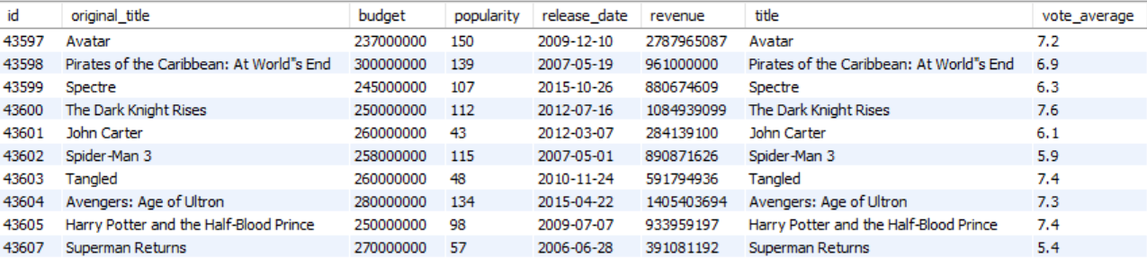

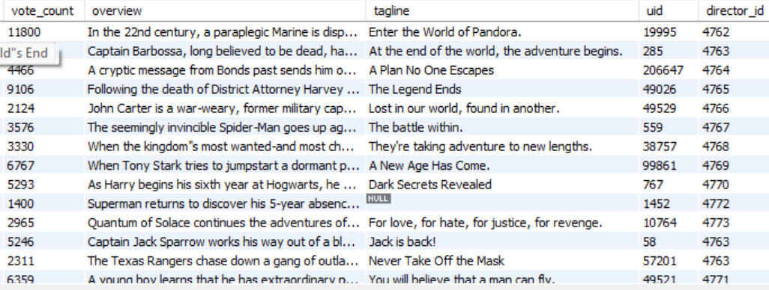

1. How do you get all data about directors?

**select * from directors;**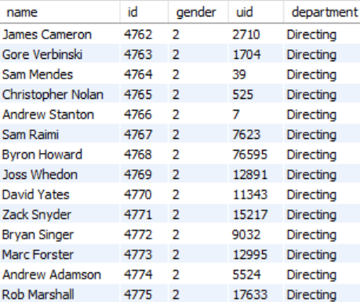

**c)** Check how many movies are present in IMDB.

**select count(*) as movie_count from movies ;**

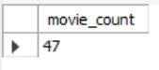

**d)** Find these 3 directors: James Cameron ; Luc Besson ; John Woo

**select * from directors**

**where name in("James Cameron", "Luc Besson ", "John Woo") ;**

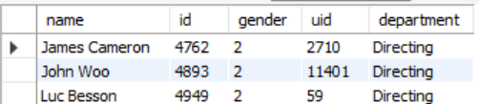

e) Find all directors with name starting with S.

**select * from directors where name like "s%" ;**

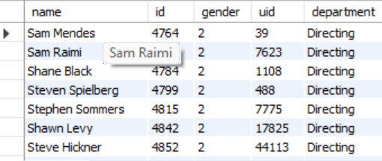

f) Count female directors.

**select count(*) as female_count from directors**

**where gender=1;**



g) Find the name of the 10th first women directors?

**select name as 10th_female_director from directors**

**where gender = 1**

**order by id asc**

**limit 1 offset 9;**



h) What are the 3 most popular movies?

**select title,popularity from movies**

**order by popularity desc**

**limit 3;**

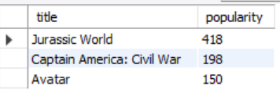

1. What are the 3 most bankable movies?

**select title, revenue from movies**

**order by revenue desc**

**limit 3;**

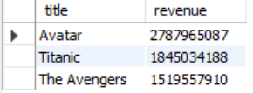

j) What is the most awarded average vote since the January 1st, 2000?

**select title, vote_average from movies where**

**release_date >= "2000-01-01"**

**order by vote_average desc**

**limit 1;**



k) Which movie(s) were directed by Brenda Chapman?

**select m.title from movies m**

**join directors d on m.director_id = d.id**

**where d.name = "Brenda Chapman" ;**



l) Which director made the most movies?

**SELECT d.name, COUNT(*) AS movie_count FROM**

**movies m**

**JOIN directors d ON m.director_id = d.id**

**GROUP BY d.name**

**ORDER BY movie_count DESC**

**LIMIT 1;**

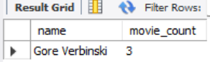

m) Which director is the most bankable?

**SELECT d.name, SUM(m.revenue) AS total_revenue**

**FROM movies m**

**JOIN directors d ON m.director_id = d.id**

**GROUP BY d.name**

**ORDER BY total_revenue DESC**

**LIMIT 1;**

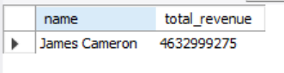

**----------------Thank you---------------**